## Used Antifreeze

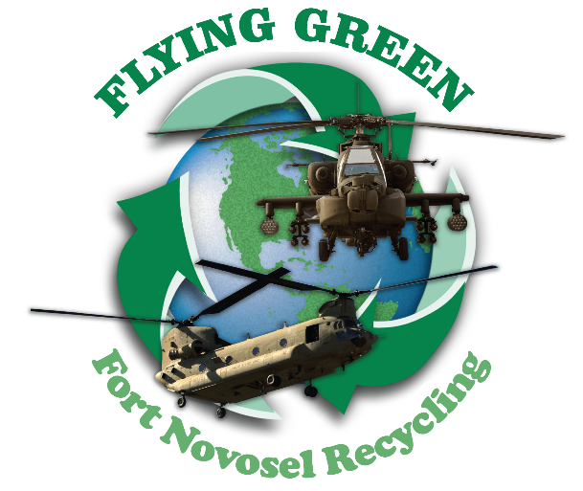

Collect in a plastic container with a lid, label as “Used Antifreeze” and turn into the HMCC (598-1037) for recycling.



**The Three Rs of Recycling**

1. **REDUCE…**use less
2. **REUSE...**put back in service without change
3. **RECYCLE…**put into service with change

## Used Batteries

Collect used batteries and turn them into the HMCC or the Recycling Center for recycling. Users must properly segregate some batteries (lithium, ni-cad, mercury, nickel metal hydride, silver-zinc and small sealed lead acid) to prevent short-circuiting during storage and transportation by either placing batteries in the original inner package, taping the positive end of the batteries, or by using plastic "baggies" to segregate individual batteries.

## Used Oil

Collect used oil in a container with a lid, label the container “Used Oil” and transfer to a collection tank. The tank located at DFMWR Auto Craft Center (BLDG 1902) can be used if no tank is located in your area. Do not leave containers of used oil unattended. Make sure the used oil is properly poured into the collection tank, and the lid to the collection tank is closed.

## Fluorescent Light Bulbs

Used fluorescent bulbs have special labeling requirements - contact DPW-ENRD (255-1024) for labels or information. Collect in original boxes and take to HMCC.

## Plastic Bags

Turn in plastic bread and grocery bags at the Commissary.

For more information on recycling

or environmental projects at Fort Novosel visit the Sustainable Fort Novosel website at:

***https:/***[***/w***](http://www.fortrucker-env.com/)***w***[***w.fortnovosel-env.com***](http://www.fortrucker-env.com/)

Please submit pickup requests @ [Sustainable Fort Novosel (fortnovosel-env.com)](https://fortrucker-env.com/programs.aspx?cur=40&program=p)

August 2023

 **Recycling Center**

Building 9322

Mayfield Ave,

Fort Novosel, AL 36362

Phone:

334-255-0468

Drop Off Hours:

0730-1530 M-F

**FORT NOVOSEL RECYCLING CENTER**

## Cardboard

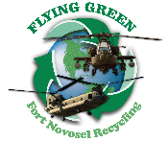

All cardboard may be recycled by bringing it to the recycling center for the incentive program. DPW-ENRD also collects cardboard from collection points across the installation. Cardboard MUST BE FLATTENED prior to placing in collection containers or bringing to Recycling Center. Call to arrange a special pick-up when moving offices or cleaning out files. If your building generates a large amount of cardboard on a regular basis, contact the Recycling Center, and they will provide a cardboard collection bin for your building and add you on the pick-up schedule. Pick-ups are NOT count ed for incentive program.

## Paper

Copier paper, writing paper, memos, index cards, glossy computer printouts, bond copier paper, manuals without metal or plastic binder, notebook paper, correspondence, fax paper, brochures, post-it notes, manila file folders, and envelopes should all be placed in collection containers and brought to the Recycling Center for the incentive program. The Recycling Center provides some 90-gallon paper recycling carts with a varied pick-up schedule. Materials picked up by the Recycling Center are NOT counted for incentive program totals.

## Aluminum Cans

Collect and bring cans to the Recycling Center for the incentive program. Keep cans segregated from other materials.

## Printer & Toner Cartridges

All types of printer and toner cartridges can be turned in at the Recycling Center. Place used cartridges in the original containers (if possible). Bring cartridges to the Recycling Center and place in designated bins.

## Used Cell Phones

Used cell phones are donated to the Cell Phones for Soldiers program and may be turned in to the Recycling Center.

## Metal

The incentive program pays organizations with DFMWR funds for bringing **SEGREGATED** recyclables to the Recycling Center. The type and quantity of materials turned in each quarter determines the monetary amounts. Materials included are aluminum cans, paper, and cardboard. Unsegregated materials and materials picked up by the Recycling Center do **NOT** count towards earned credits in the program. See ENV-SW011, *Recycling Incentive Program*, for detailed information about the program.

**INCENTIVE PROGRAM**

All scrap metal and metal furniture not on a hand receipt can be turned in at the Recycling Center.

## Wood

All wood products to include pallets, crates and wooden furniture not on a hand receipt may be delivered to the wood lay down yard beside DLADS. All heavy metal (i.e., handles, hinges, coaster wheels) will need to be removed prior to delivery. Call 255-9041 to schedule an appointment at the yard.

## Electronics

Discarded electronic equipment (e-waste) such as computers, TVs, tablets, charging cord/wire, copiers/printers, DVD/CD/MP3 players, clocks and audio equipment can be dropped off at the Recycling Center during normal business hours.

MICROWAVES, REFRIGERATORS, and HAND RECEIPTED ITEMS WILL NOT BE ACCEPTED.

August 2023

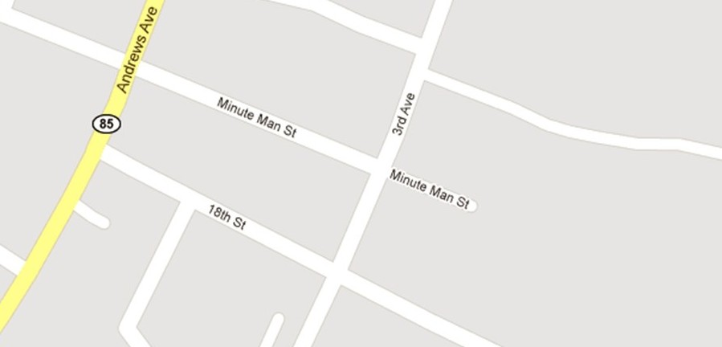

Recycling Center is located at Bldg. 9322 on Mayfield Avenue